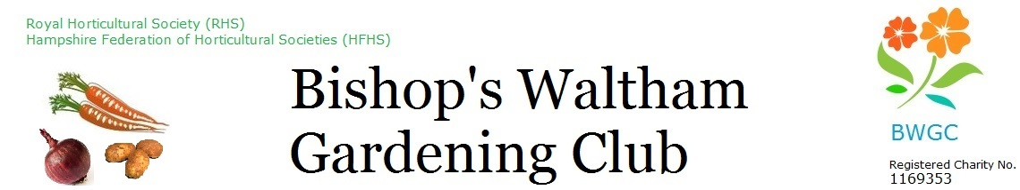
For Admin only
Name

MemNo

PlotNo

Membership and allotment application 2025-6

- Complete one form per applicant. One applicant can pay the membership fee for other applicants.
- If you are a UK taxpayer please consider completing the Gift Aid Declaration so the Club may reclaim the tax you paid on your membership fee. We receive £1.50 for each member covered by a Gift Aid declaration.

1. Your details
Title Forename: Surname:

Address Postcode

Telephone Mobile

Email

Do you want to apply for an allotment? Y N Perhaps later…(see Notes in Section 7)

2. Gift Aid
Gift aid declaration
Name, address as above in Section 1

I want Bishop's Waltham Gardening Club to collect Gift Aid on my membership fee and any membership fees I pay in subsequent years.
I am a UK taxpayer and understand that if I pay less income tax and/or capital gains tax than the amount of Gift Aid claimed on all my Gift Aid donations it is my responsibility to pay any difference.

Signed Date

You can also make your declaration using the form on our website https://www.bwgc.org.uk/Membership/
To cancel the declaration notify Bishop's Waltham Gardening Club (bwgc-membership@bwgc.co.uk). For additional information on Gift Aid refer to https://www.gov.uk/donating-to-charity or seek professional advice.

3. Membership fee
Please complete this table indicating your total fees.
Membership fee (£6 per person per year) |  |  |  | £6
I also enclose membership fee for [name, address]

Total to pay
Payment Method | BACS/Online Bank Transfer |  | Cheque |  | Card

4. Emergency contact details (optional). Only to be used by a trustee in event of real emergency.
Name

Relationship Phone number

See over for payment methods, returning the form and agreement.

5. Payment methods.

Payment by BACS/bank transfer (preferred)
For BACS/online bank transfer please pay:
- account name Bishops Waltham Gardening Club;
- sort code: 30-90-85,
- account number: 00125311
- reference; surname & postcode.

Payment by cheque
Please make cheques payable to: Bishops Waltham Gardening Club. Send it, with this completed form to:
BWGC Membership Secretary, 1 Shore Lane , Bishop's Waltham, SO32 1DY, or leave it at The Shop.

Payment by card
You can pay by credit or debit card at The Shop at the allotments. The Shop is open on weekends from 10AM to midday from the beginning of February until the end of October.

6. Returning the application
Once payment is made, return this completed form to: bwgc-membership@bwgc.co.uk, or to BWGC membership secretary, 1 Shore Lane, Bishop's Waltham, SO32 1DY. There is no need to provide a hard copy / wet signature.

7. Privacy
By submitting a completed form all members consent to the collection and retention of the personal data supplied on this form for the purposes specified in the Bishop's Waltham Gardening Club Privacy Notice available at https://www.bwgc.org.uk/gallery/GDPR-Privacy-Notice.pdf or by request to bwgc-info@outlook.co.uk

In summary, the Club trustees will hold this data for the purposes of communication, Club administration and HMRC Gift Aid. You have the right (1) to access or amend your personal data, (2) to have your personal data deleted if there is no reason for its continued storage and processing, (3) to restrict the processing of your personal data, and (4) to withdraw your consent for the use of your data.
----------------------------------------------------------------------------------------------------------------------------------

8. Notes / Brief information for new members

- The main method of communication with members is by email. If you do not receive occasional emails, or if you change your email address, please let us know.
- Our website has lots of useful information about events, benefits of membership etc.
- Our Facebook page has useful up-to-date information, e.g. about additional Shop opening hours.
- Allotment holders should familiarize themselves with the rules in the Tenancy Agreement. These apply to all members who work on plots.
- All adults who regularly spend time on the allotments must be members.
- If you would like to apply for an allotment, please indicate this in Section 1, and also send an email to bwgc-allotments@bwgc.co.uk . The allotments administrator will be in touch when a suitable plot becomes available. Please do NOT pay plot rental in anticipation of getting a plot.

